HW 7 Report
Tailang Cao u1480633
Msdscript0:
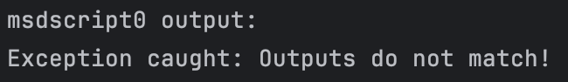
Not returning any result for any test, failing every test.

Msdscript1:
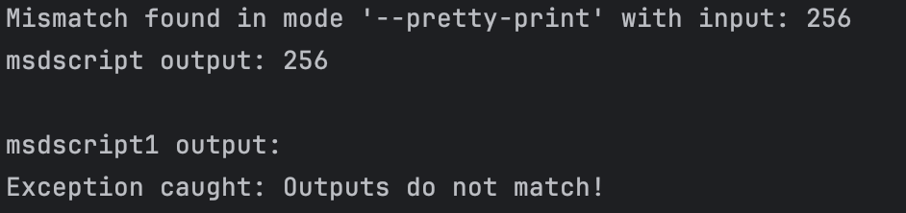
Not returning any result for any test, failing every test.

Msdscript2:
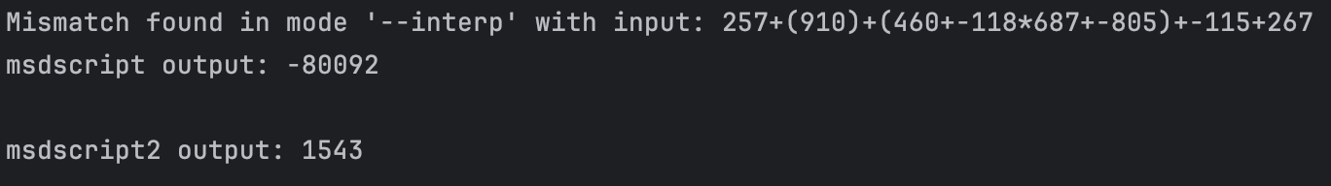
Not returning any result for number interp.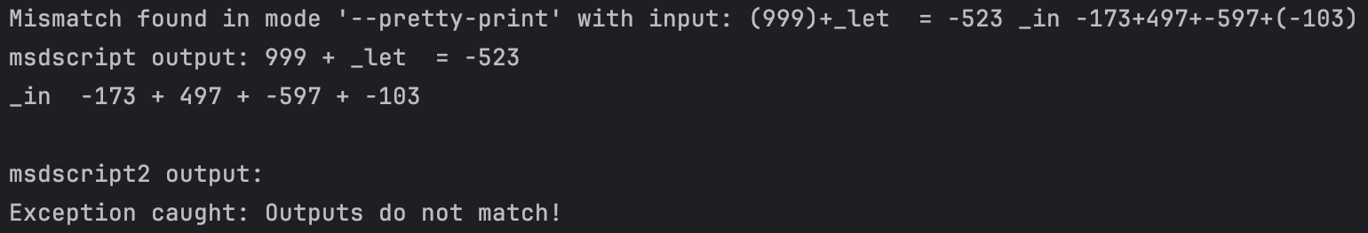
Failing pretty print and print for let expression.

Msdscript3:
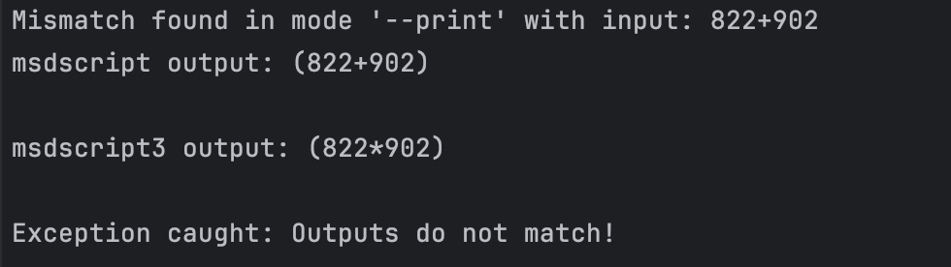
Failing print for add expressions, printing multiplication instead;
Failing pretty print for let expressions, not returning anything.

Msdscript4:
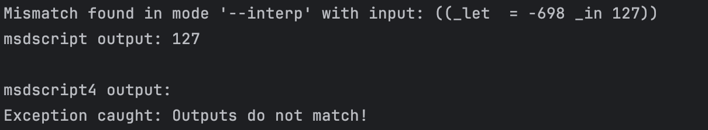
Failing print and pretty print for let expression.

Msdscript5:
Failing pretty print for let expressions.

Msdscript6:
Failing pretty print and print for let expressions.

Msdscript7:
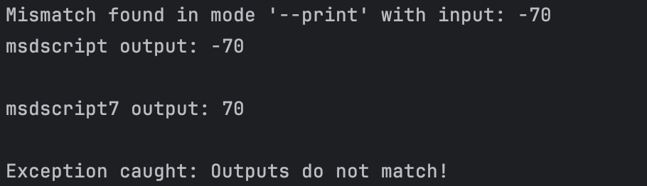
Failing interps, print, pretty print of negative numbers
Failing pretty print for let expressions.

